|  |  |  |  |
| --- | --- | --- | --- |
| Name:  Class: | ____________________________________  ________________ | | Date:_________ |
|  | **Year 11 Essential Mathematics 2018**  / 13  Weighting: 1%  **Mini-Test 1.6**  **Topic – Units of Energy – Practical Applications** | | |
| **Total Time:** | 15 minutes |  | |
| **Weighting:** | 1% |
| **Equipment:** | To be provided by the student: Pen, pencil, ruler,1 single sided A4 page of notes, scientific calculator | | |

**Full working out must be shown to get full marks. Attempt all questions.**

|  |
| --- |
| **Question 1** **4 marks** |

Convert the following:

1. 5 kW to W b) 2670 W to kW c) 589 W to kW d) 4.23 kW to W

|  |
| --- |
| **Question 2** **3 marks** |

Find the energy used by:

1. 850 W washing machine used for 2 hours

1. 100 W laptop used for 4 hours, 30 minutes

1. 350 W electric blanket used for 45 minutes

|  |
| --- |
| **Question 3** **4****marks** |

While preparing breakfast, Terry used a 1520 W toaster for 12 minutes, a 2200 W kettle for 6 minutes, and a 300 W blender for 3 minutes.

1. Which appliance used the most energy? Support your answer with reasoning.

|  |
| --- |
| **Question 4****5****marks** |

1. Fill in the missing information on this power bill.

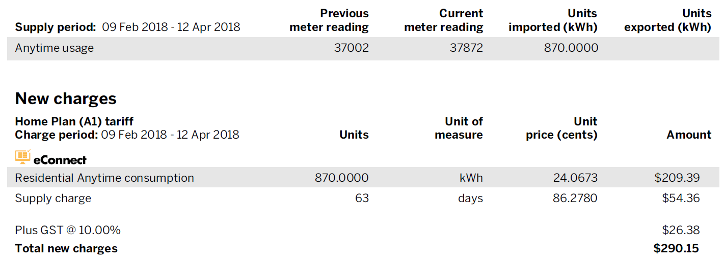

1. What is the average daily use of energy during the billing period?